**Team Memo - Guide for testing GitTrust v0.0.0000001**

1. Download PyCharm from https://www.jetbrains.com/pycharm/

Note about PyCharm versions: the free community version is enough to run the code, but your university account also allows you to use the professional version for FREE.

2. Install PyCharm

3. Open the project root folder as a PyCharm folder (file>open; or right click on folder and “open as PyCharm project”)

4. If everything is correct, your project structure should look like this (you may not have venv folder. It is the Python virtual environment – basically a fresh copy of Python used only for this project. You don’t need it, but if you want, you could find information by searching “virtual environment with PyCharm”) :

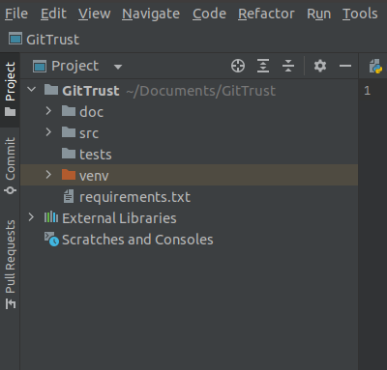

5. go to the terminal on the lower half of the window, which looks like this:

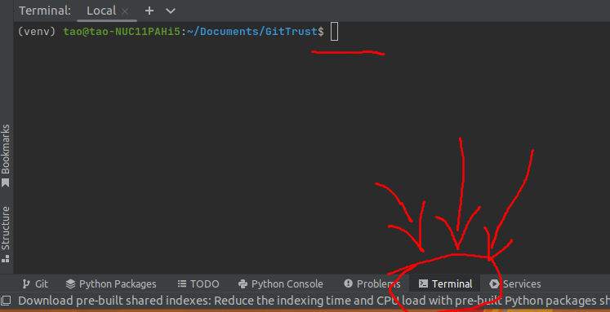

6. pip install all project dependencies with:

pip install -r requirements.txt

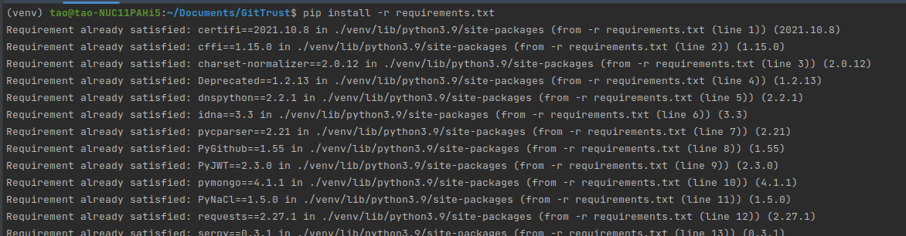

7. then, right click on main.py and click “run”. For the first time, PyCharm will ask you to set configuration. You need to set environment variables here.

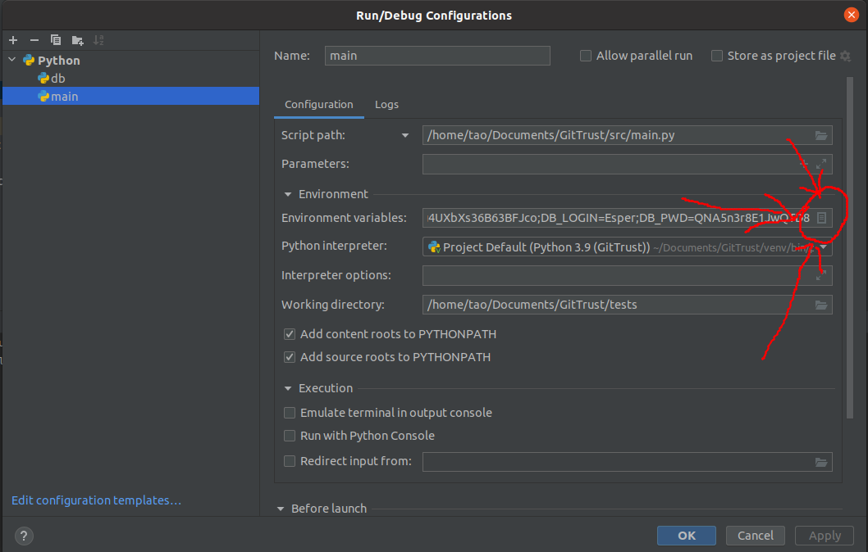

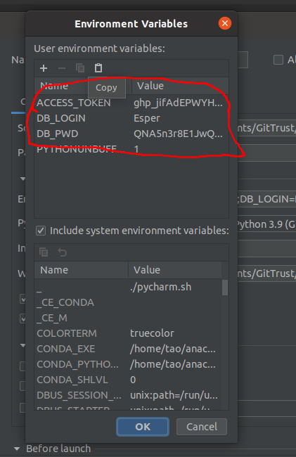

If you can’t find run/debug configuration, find “edit configurations” here:

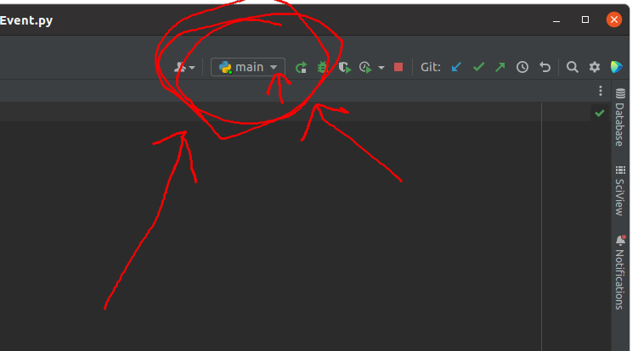

8. Then main.py will run. PyCharm will remember your configurations (for now we are using a free database, please don’t run this on very large repositories!

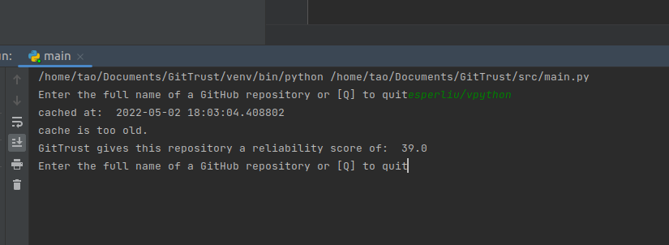(I know very little information is provided here in the CLI, but I promise, lots more things happen in the background)